

How to update your email signature
- Choose one of the three approved signature files listed at the bottom of this document.

- Select the full signature between the two ==== lines

- Hit Ctrl+C to copy the signature
In Outlook:
- Open a new message
- Click on “Signatures” button and then select “Signatures…” to edit your signature
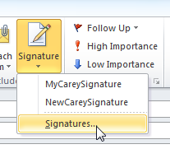
- Click on your signature and select the entire text of the signature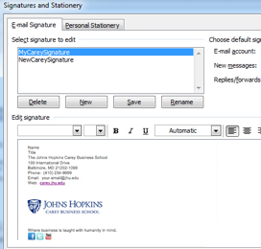

- Hit Ctrl+V to replace the selection with the new signature
- Modify your name, title, phone, address and email address
- Click “OK” to save.
- Create a new message to make sure the signature is correct.

COPY THE NEW SIGNATURE FROM HERE (Font: Calibri / 9pt):
================

Name
Title
Johns Hopkins Carey Business School
100 International Drive / Baltimore, MD 21202
410.234.9999
your.email@jhu.edu
  


================

==================
ALT OPTION 2 [multiple numbers]
================

Name
Title
Johns Hopkins Carey Business School
100 International Drive | Baltimore, MD 21202
Office: 410.123.4567 | Cell: 410.123.4567 | Fax: 410.123.4567
your.email@jhu.edu

==================
ALT OPTION 3 [with safezone graphic]
================

Name
Title
Johns Hopkins Carey Business School
100 International Drive | Baltimore, MD 21202
Office: 410.123.4567 | Cell: 410.123.4567 | Fax: 410.123.4567
your.email@jhu.edu



==================
ALT OPTION 4 [multiple numbers horizontal option]
================

Name
Title
Johns Hopkins Carey Business School
100 International Drive | Baltimore, MD 21202
Office: 410.123.4567 | Cell: 410.123.4567 | Fax: 410.123.4567
your.email@jhu.edu
SCHEDULE A PHONE CALL

Please do not add additional logos and icons to your email signature.
Consult the school’s Identity guidelines for more information on email signature best practices.

